Chuanjie ZANG

699382953

Step 1 :In the right side of the Layers panel, click on the bottom of the new layer, double-click the layer name to change to 'landscape', select this layer, and select 'ellipse tool'. Draw a square circle in the 'landscape' layer, overlapping the landscape photo. Then use the shift key to select the circle and the landscape photo, and select 'object - clipping mask - make' in the control bar.

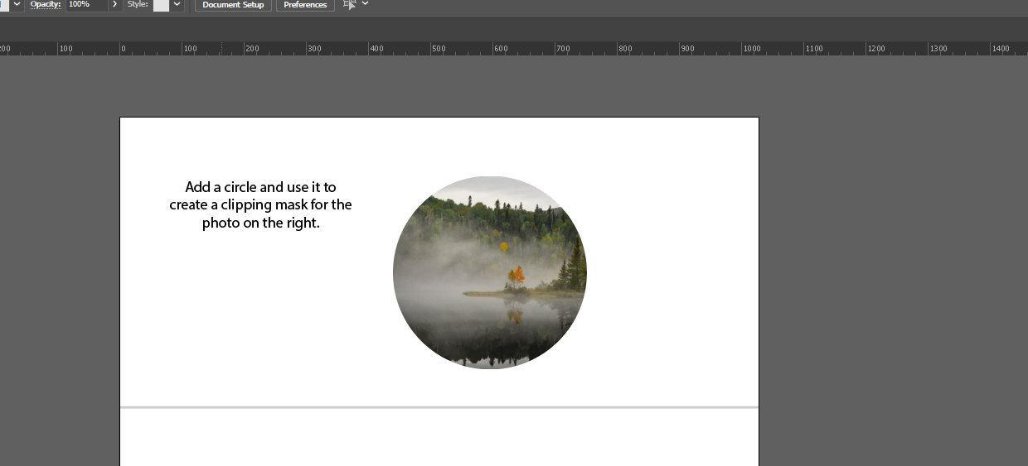

Step 2 :Create a new layer named 'France', copy the france shape, then select the 'France' layer and paste the france shape. note that the 'paste remember layers' in the Layers panel cannot be selected during this step. Next gropu the elements of the cycling illustration, then use shift to select the france shape and the illustration and use 'clipping mask - make'. Then ungroup the illustration, then select the illustration elements that need to be adjusted from the right side of the layers panel.

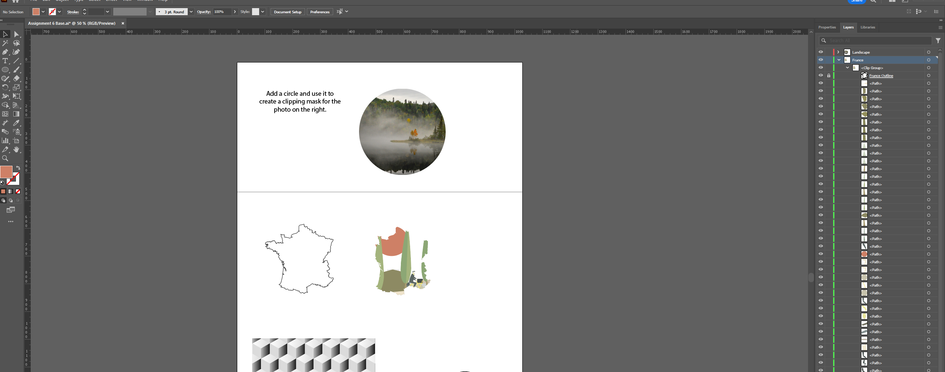

Step 3 : Duplicate 'mask', create a new layer and name it 'Text', select the Text layer and duplicate 'mask' into the Text layer. Move the mask over the texture pattern, use shift to select the mask and the texture pattern, select 'clipping mask - make'.

